https://reputationtoday.in/in-conversation-with-wole-adamolekun/

Source: 

In Conversation with Wole Adamolekun
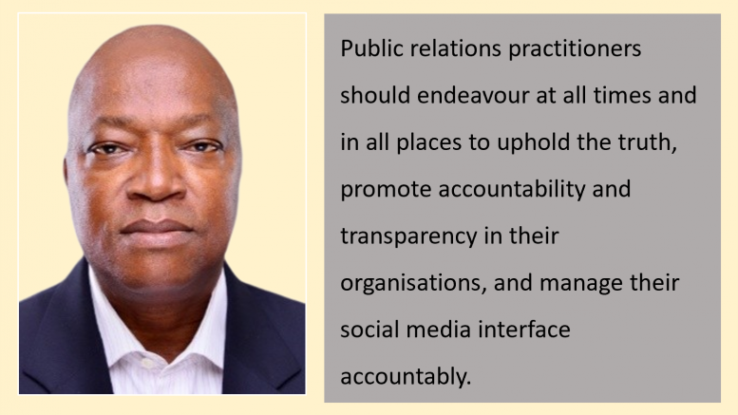
POSTED BY: HEMANT GAULE DECEMBER 21, 2023
In an exclusive interview with Reputation Today, Dr. Wole Adamolekun from Elizade University reflects on his journey since receiving the Best Public Relations Practitioner Award in 1995. He discusses how public relations have evolved over the years, emphasising the strategies and skills he developed to remain relevant and excel in the field. We delve into the significant changes he’s observed in Corporate Communications over four decades and their impact on organisational communication with stakeholders. Dr. Adamolekun shares his insights on the collaboration between PR professionals and CSR teams for effective communication of ethical values. He also offers strategies for PR teams to enhance transparency and accountability in corporate ethics. Finally, we explore his views on the future of PR education in adapting to a rapidly changing media landscape, along with advice for aspiring PR professionals.
Hemant Gaule: Receiving the Best Public Relations Practitioner Award in 1995 is quite an honour. How has the field of public relations evolved since then, and what strategies or skills have you developed to stay relevant and excel in your profession over the years?
Dr. Wole Adamolekun: The Award was a culmination of my chairmanship of the Abuja Chapter of the Nigerian Institute of Public Relations (NIPR). The challenge at that time was the limited understanding of the public relations profession by employers and even the practitioners. While the employers thought public relations was protocol and general duties, most practitioners acted as through their main task was media relations. We embarked on massive awareness visits to organisation and ensured training and retraining of our members. Over the years, a lot has changed and the profession is better recognised and the practitioners, as employees and consultants have been able to upscale their skills and deliverables. On a personal level, I realised early in my career that research capability and data analysis are critical to effective communication and organisational counseling. Armed with these additional skills, my journey to the c-suite was assured as I became a ready resource for top management and the board in policy formulation, decision making and implementation. Thus it was possible for me to move from government youth service programme, political and social mobilisation, community banking and downstream petroleum sector at the highest levels.
HG: What significant changes have you witnessed in the Corporate communications field over the past four decades, and how have these changes impacted the way organisations communicate with their stakeholders?
WA: Most government organisations in the public service, education, armed forces and police employ information officers who basically pass information about government activities to the citizenry through the traditional mass media of print and electronic media. During that period, most officers were mere information disseminators as they had very limited influence on policy formulation and decision making. In fact, most officials performing the information and communication functions were known as information, press or even administrative officers. Today, the story is different as government and its consultancies have embraced public relations practices in all governance structures. By 1990, government approved that its communication officers can rise to the position of Directors and made membership of the professional institute, the Nigerian Institute of Public Relations a prerequisite for career advancement. Nigeria is among the few countries in the world that have a law backing the practice.
Conversely and form historical perspective, the private sector understood the need for effective communication with their various stakeholders and audiences and so they embraced public relations as a tool for business success from the onset. For the private sector actors such as operators in oil and gas companies, financial institutions, telecommunication companies, manufacturers and other multinational and transnational corporations the practice of public relations has developed progressively. These organisations have always used the hybrid of in-house professionals and consultants to achieve their corporate goals. In doing this, they have adopted technology at every stage of its compelling positive influence on business efficacy and return on investment.
HG: Can you share insights on how public relations professionals can collaborate with CSR teams to ensure that ethical values are not only integrated into the company’s culture but also effectively communicated to the public?
WA: Corporate Social Responsibility is the recognition by organisations that they derive their license to operate from the public and that there is a need for them to constantly do their business ethically, fairly and sustainably. As a matter of fact, companies that are socially responsible have been found to have comparative advantage over their competitors, improved profitability and are sought after dream workplaces. Such organisations do not see their social responsibility interventions as adhoc but as an integral part of their operations. Of course, corporate social responsibility practices in organisations yield better results when the programmes are collectively designed, executed and evaluated. The teamwork that corporate social responsibility engenders in organisations is what determines its success as the buy in by all strata of the organisation from the bottom to the top leads to sustainability and lasting impact. Milton Freidman’s argument that business has no need to engage in social welfare programmes but focus solely on making profit for its owners so that they can decide what to do with it always come to mind whenever there is global economic ruptures such as we have now. This is because business challenges may make companies unable to operate profitably but COVID-19 pandemic has taught the world that there is need for more and sustainable social responsibility gestures as profit making should not be a determinant for acts that makes the society better.
HG: When discussing corporate ethics, what strategies or communication approaches do you recommend for PR teams to foster transparency and accountability within organisations?
WA: Ethics is one of the hallmarks of public relations as it emphasises truth telling, accountability and transparency of the practitioners in carrying out their relational responsibilities. Technology has revolutionised information gathering, processing and dissemination worldwide and the dichotomy between print and electronic media has been greatly narrowed courtesy of the internet and the myriads of digital platforms that are now available to all. As great as these technologies have been, they have also come with its challenges principally because of the untrained corps of citizen journalists who bombard the social media platforms with misinformation, disinformation and misinformation with reckless abandon. Unfortunately, the ‘freedom’ of expression mantra makes managing this specter difficult. Therefore, public relations practitioners should endeavour at all times and in all places to uphold the truth, promote accountability and transparency in their organisations, and manage their social media interface accountably.
Strategies that can make ethical practices in managing corporate social responsibility succeed include designing clear and achievable objectives, using internal communication, ensure that the entire organisation participate in the programme, active involvement of the benefiting communities and other stakeholders and deliver on corporate values of productivity and service delivery.
HG: The PR industry is known for its fast-paced nature and constant adaptation to new trends. How do you see PR education staying relevant to meet the demands of an ever-changing media landscape, and what advice do you have for aspiring PR professionals in this context?
WA: Public relations according to Edward Bernays is an art applied to science. This being the case, public relations is research oriented and scientific in approach. This is why public relations cover every aspect of human endeavour and responds to societal changes as they occur. Public relations by its very nature has benefited from a groundswell of educational materials for training and continuous education. The public relations pioneers deliberately developed the practice on a robust educational structure which has created a body of knowledge in such areas as governance, finance, reputation building, issues and crisis management, media relations, corporate social responsibility, organisational counseling, strategic communication, community relations among several others. Public relations pedagogy in higher institutions and those offered by professional institutes have adapted relevant technologies to deliver both online and physical contacts education that responds to the realities around us.
Public relations trends in this new era of virtual workplace, entrepreneurship, and accentuated demand for targeted and strategic communication, strategic media exposure of quality-over-quantity opportunities will predominate, public relations impact on business can be easily evaluated. Artificial Intelligence is a reality that organisations have to understand and adapt to, social media platforms will continue to dominate information dissemination, diversity, equity and inclusion (DEI) matters are trending, partnerships with influencers are now regular features in product branding, authenticity will reduce the negative impact of fake news and disinformation and media relations will continue to be relevant but not dominant.
Aspiring public relations practitioners should take advantage of the body of knowledge that has been developed over the years to properly understand its importance to societal development and attainment of a better and more sustainable universe.

The responses above are from Wole Adamolekun as shared with Reputation Today

